Day 1
Things that will be covered
Azure Cloud – Required for DevOps
Linux
Git
Azure Repos
JIRA or Azure Boards
Pipelines
IaC – Terraform and Bicep
Docker and Kubernetes – 20 days – Prometheus and Grafana
Project
Interview Questions – Scenario Based questions

Resume Building & LinkedIn Optimization
Monster and Dice Portals like Naukri for US people

Day 1 Notes
What is a computer ?
Fundamental use case of Computer is
Take Input-> Process the data -> Store the data -> Output the data
Hardware
CPU
RAM
Storage
NIC – Wifi and Ethernet
I/O
GPU

Software
OS – To interact to fulfill our requirements
Windows/Linux/Mac
Applications –

Server – Similar to Computer
User will send a request to Server -> Server will process the request -> Server will respond to the request
Hardware Configurations
CPU
RAM
NIC
Storage
----
Reliability
High performance
Secured
24/7 availability
Software – We have to utilize the maximum potential of Hardware that we install to get the maximum possible efficiency in software.

If we install Hypervisor on Physical server, we are enabling the feature of using multiple virtual servers.
Creating virtual servers on top of Physical servers with minimized capabilities.
These virtual servers will also have OS/Applications

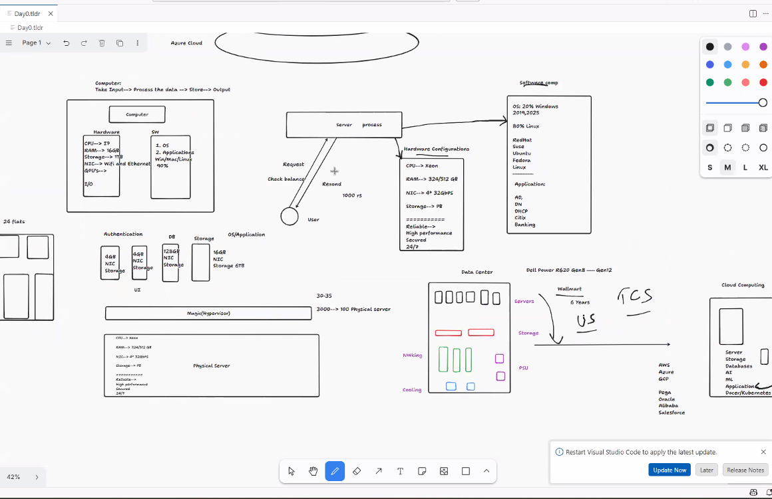

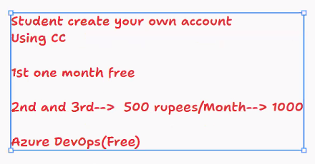
What is Service Connections in Azure? Integrating multiple applications into Azure

How much time are we getting for Powershell scripting, Groovy scripting, ? Azure CLI will be there, YAML, Azure, Terraform
What do you mean Pipelines -> Scripting or Declarative ? ? Azure Devops pipelines will be taught, Github actions also
Till what level Networking concepts, Security will be revised? Only few layers of OSI will be convered
Red letters in Curriculum ? Security related concepts
How many days each topic takes? Any timeline ?
How much do they expect for a 4 years experience ?
Timings?

